Coordinated Universal Time (UTC)

Definition:
# Source: AI Source: Provided by: [Data Path: Persons Table -> ID Column: 1, Name_En Column: Motasem Essam] -> From: [Chatgpt (GPT‑5 Mini)] on [1/26/2026]
Coordinated Universal Time (UTC) is the primary standard for timekeeping worldwide. It serves as the reference time from which all local time zones are calculated.

Key Points
# Source: AI Source: Provided by: [Data Path: Persons Table -> ID Column: 1, Name_En Column: Motasem Essam] -> From: [Chatgpt (GPT‑5 Mini)] on [1/26/2026]
- UTC is not affected by Daylight Saving Time (DST).
- It is based on atomic clocks and astronomical observations.
- Often used in computers, aviation, internet systems, and international communications to avoid confusion caused by time zones.
- Sometimes referred to as GMT (Greenwich Mean Time), but technically GMT is a time zone, while UTC is a time standard.

How Time Zones Relate to UTC
# Source: AI Source: Provided by: [Data Path: Persons Table -> ID Column: 1, Name_En Column: Motasem Essam] -> From: [Chatgpt (GPT‑5 Mini)] on [1/26/2026]
- Local times are defined as an offset from UTC.
- Example:
  - UTC+5:30 → India Standard Time (IST)
  - UTC-8 → Pacific Standard Time (PST)

Example
# Source: AI Source: Provided by: [Data Path: Persons Table -> ID Column: 1, Name_En Column: Motasem Essam] -> From: [Chatgpt (GPT‑5 Mini)] on [1/26/2026]
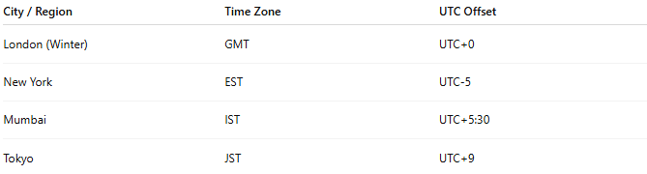
City / Region | Time Zone | UTC Offset
London (Winter) | GMT | UTC+0
New York | EST | UTC-5
Mumbai | IST | UTC+5:30
Tokyo | JST | UTC+9

Usage
# Source: AI Source: Provided by: [Data Path: Persons Table -> ID Column: 1, Name_En Column: Motasem Essam] -> From: [Chatgpt (GPT‑5 Mini)] on [1/26/2026]
- Internet protocols like HTTP, SMTP, and FTP use UTC timestamps.
- Programming: Many programming languages store date-time in UTC to avoid confusion when users are in different time zones.
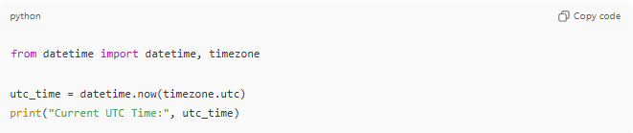
from datetime import datetime, timezone

utc_time = datetime.now(timezone.utc)
print("Current UTC Time:", utc_time)

Analogy
# Source: AI Source: Provided by: [Data Path: Persons Table -> ID Column: 1, Name_En Column: Motasem Essam] -> From: [Chatgpt (GPT‑5 Mini)] on [1/26/2026]
- UTC → Universal “master clock”
- Time zones → Local clocks set relative to the master clock

✅ Summary
# Source: AI Source: Provided by: [Data Path: Persons Table -> ID Column: 1, Name_En Column: Motasem Essam] -> From: [Chatgpt (GPT‑5 Mini)] on [1/26/2026]
- UTC = Worldwide reference time standard
- Used to synchronize time globally
- Basis for time zones and international communication

